**Exercise No:2**

**Date:14/10/2020**

**Aim:**

To Write a Python function countX(lst, x) to count the number x in a given list of numbers.

**Program:**

def countX(lst,x):

count = 0

for element in lst:

if element==x:

count = count+1

print(count)

lst=[]

n=int(input())

for i in range(0,n):

element = int(input())

lst.append(element)

x=int(input())

countX(lst,x)

**Link:**

<http://103.53.53.18/mod/vpl/forms/edit.php?id=230&userid=1708#>

**Output:**

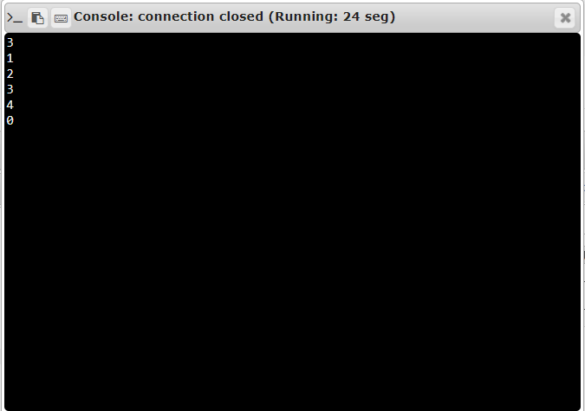

**Result:**

The Python program to count the number x in a given list of numbers is executed.